Task – 20
Checking AWS Identity
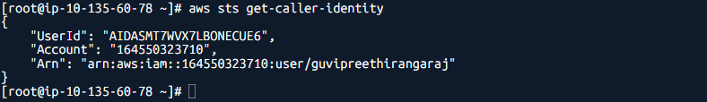
Installed Terraform
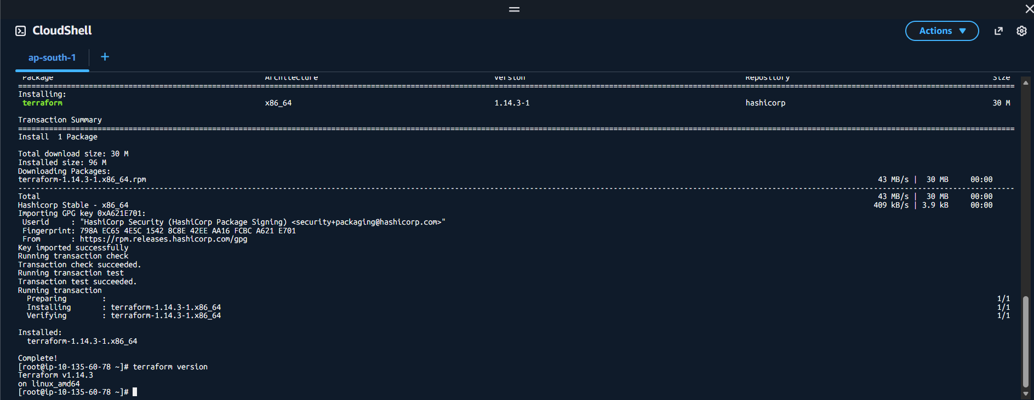
Created directory and files
Terraform init
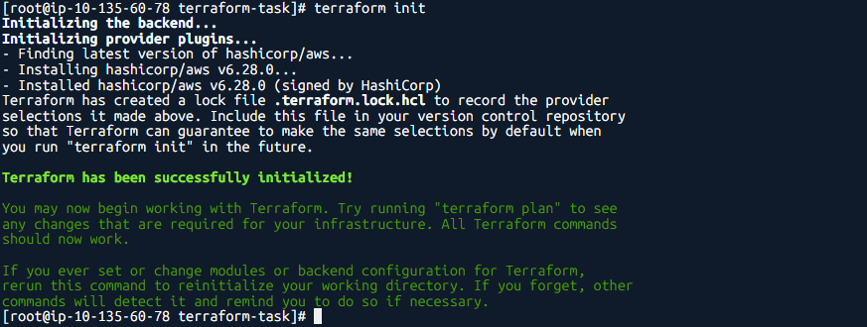

Terraform plan
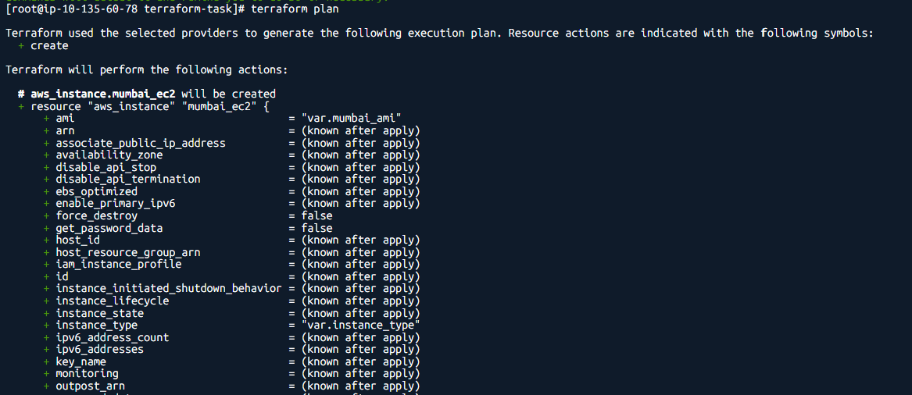
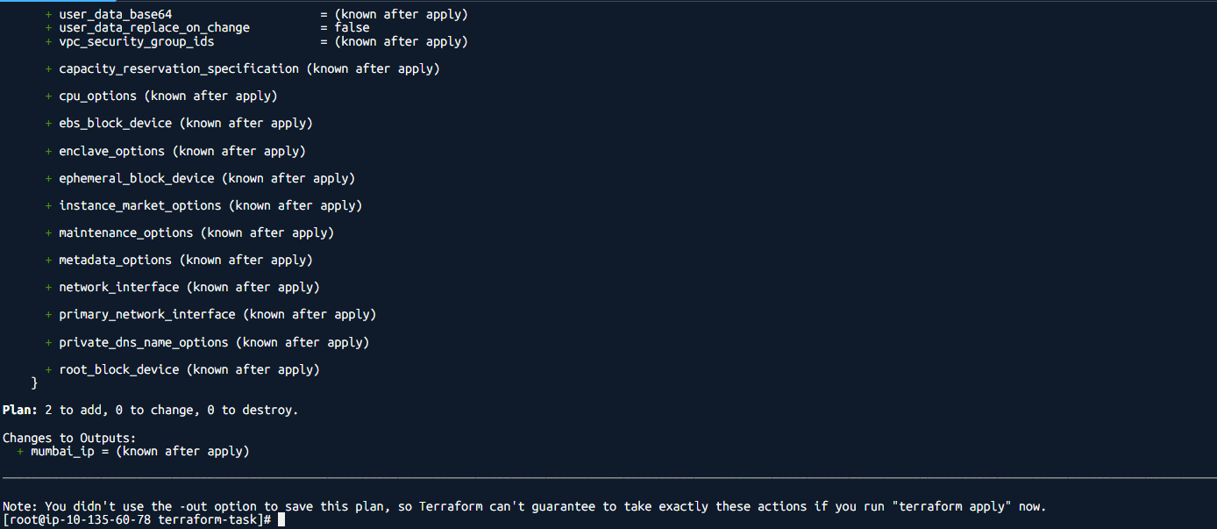
Terraform apply
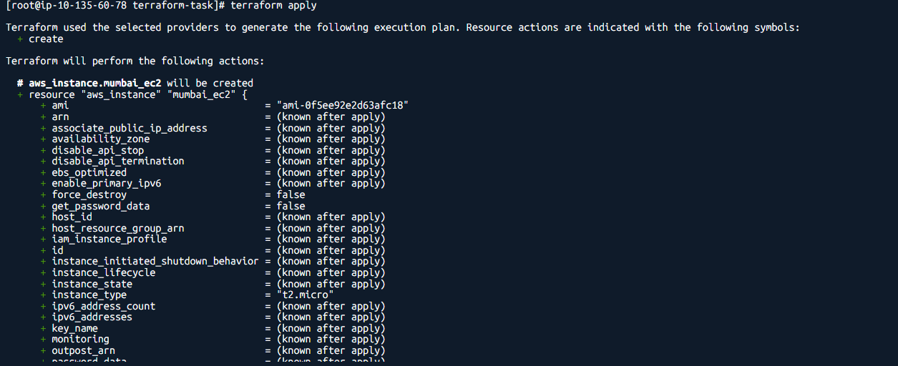
AS GUVI doesn’t allow to create instance in Singapore it shows error. Instance created in Mumbai region.
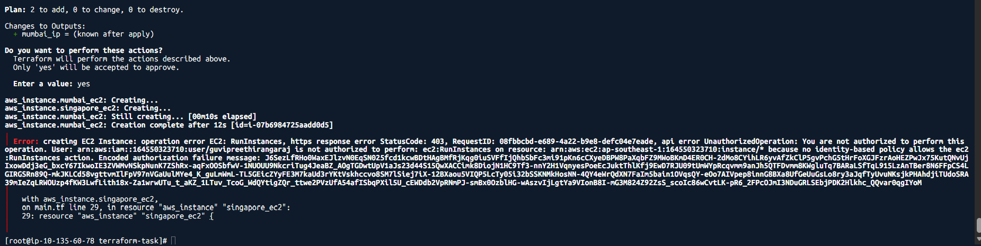
Instance Created in Mumbai region
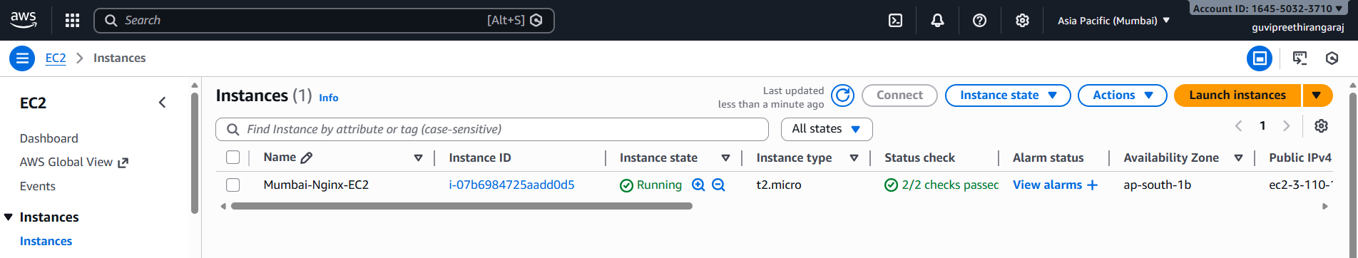
Website created
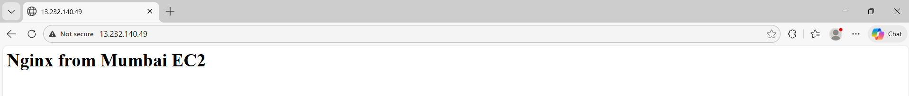

Main.tf
provider "aws" {
region = "ap-south-1"
}

provider "aws" {
alias = "singapore"
region = "ap-southeast-1"
}

# Security Group
resource "aws_security_group" "nginx_sg" {
name = "nginx-sg"
description = "Allow SSH and HTTP"

ingress {
from_port = 22
to_port = 22
protocol = "tcp"
cidr_blocks = ["0.0.0.0/0"]
}

ingress {
from_port = 80
to_port = 80
protocol = "tcp"
cidr_blocks = ["0.0.0.0/0"]
}

egress {
from_port = 0
to_port = 0
protocol = "-1"
cidr_blocks = ["0.0.0.0/0"]
}
}

# Mumbai EC2
resource "aws_instance" "mumbai_ec2" {
ami = var.mumbai_ami
instance_type = var.instance_type
key_name = var.key_name
vpc_security_group_ids = [aws_security_group.nginx_sg.id]

user_data = <<-EOF
#!/bin/bash
apt update -y
apt install -y nginx
rm -f /var/www/html/index.nginx-debian.html
echo "<h1>Nginx from Mumbai EC2</h1>" > /var/www/html/index.html
systemctl restart nginx
systemctl enable nginx
EOF

tags = {
Name = "Mumbai-Nginx-EC2"
}
}

# Singapore EC2 (will fail in GUVI but kept for multi-region proof)
resource "aws_instance" "singapore_ec2" {
provider = aws.singapore
ami = var.singapore_ami
instance_type = var.instance_type
key_name = var.key_name
vpc_security_group_ids = [aws_security_group.nginx_sg.id]

user_data = <<-EOF
#!/bin/bash
apt update -y
apt install -y nginx
rm -f /var/www/html/index.nginx-debian.html
echo "<h1>Nginx from Singapore EC2</h1>" > /var/www/html/index.html
systemctl restart nginx
systemctl enable nginx
EOF

tags = {
Name = "Singapore-Nginx-EC2"
}
}
Output.tf
output "mumbai_ip" {
value = aws_instance.mumbai_ec2.public_ip
}
Variables.tf
variable "instance_type" {
default = "t2.micro"
}

variable "mumbai_ami" {
# Ubuntu 22.04 - Mumbai
default = "ami-03f4878755434977f"
}

variable "singapore_ami" {
# Ubuntu 22.04 - Singapore
default = "ami-0df7a207adb9748c7"
}

variable "key_name" {
# Your AWS keypair name
default = "nginx"
}

